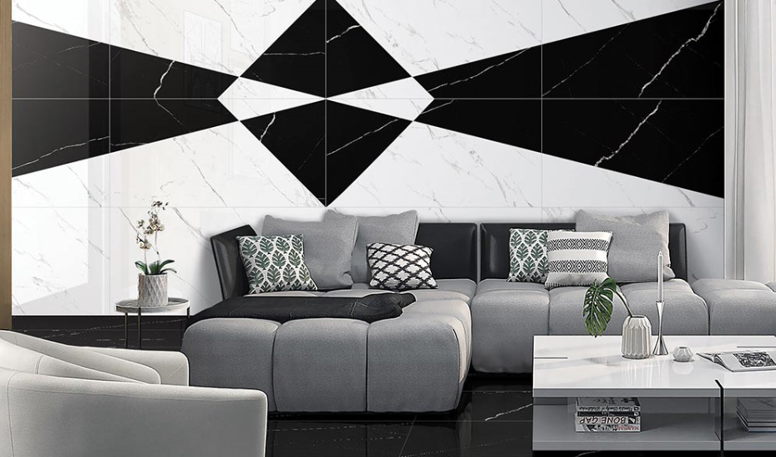

**LIVING ROOM**

Our living room wall tiles selection includes glazed porcelains from the US manufacturer, Adeline. Italian politano and arancetto

marbles now available in Polished finishes.

Available in a wide variety of sizes, shapes, and mosaics.

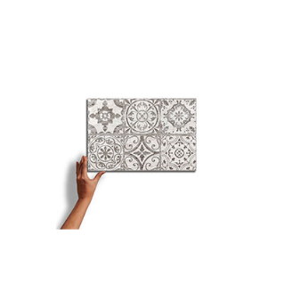

**Lasa Bianco**

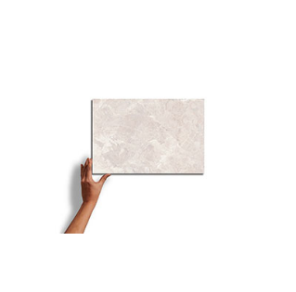

***Sandstone Grey***

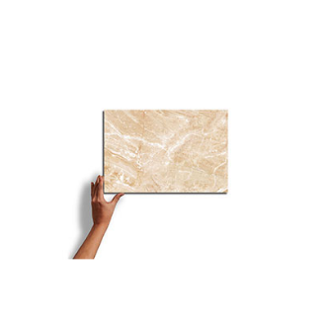

***Lyptus Honeywod***

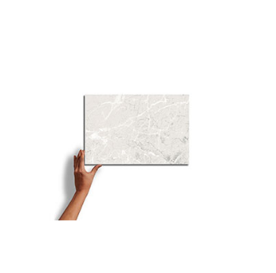

***Orfeo Buff***

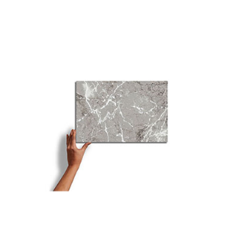

***Doughlas Fir Natural***

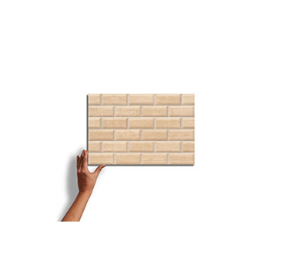

***Laufen Gold Decor***

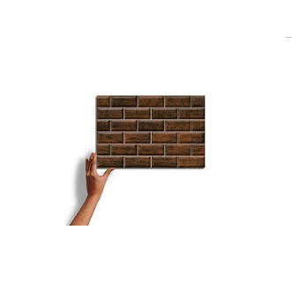

***Laufen Brunette***

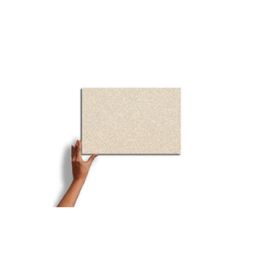

***Laufen Gold***

**LIVING ROOM WALL TILES** TECHNICAL INFORMATION

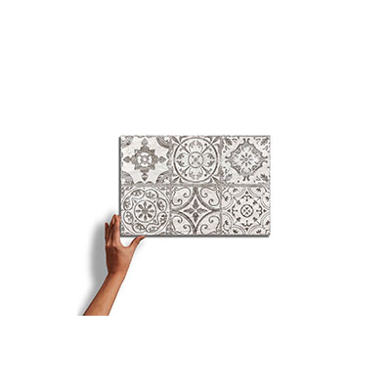

**LASA BIANCO**

A beautifully glazed porcelain collection from Italy creates a blend of marbles with a subtle antiqued look. Blending the veining of white Italian marbles (Carrara, Statuario, Gioia, and Venatino) in both White and Black creates a variety of sizes and patterns to create custom designs.

SPECIFICATIONS

**Country of Origin**

Italy

**Wear Rating**

Class 5 Suitable for all Residential and Commercial Application. Class 5 tiles are suitable for all applications including those with heavy traffic and constant use. (i.e., Shopping Malls, Hospitals), Class 3 Residential Applications. Suitable for all residential applications.

**Shade Variation**

V3 - Moderate Variation While the colors present on a single piece of tile will be indicative of the colors to be expected on the other tiles, the amount of colors on each piece will vary significantly.

**Frost Proof**

Yes

**Finish**

Glazed

**Material**

Porcelain

**Bullnose**

Yes

**LIVING ROOM WALL TILES** TECHNICAL INFORMATION

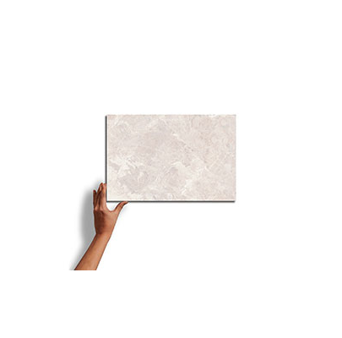

**SANDSTONE GREY**

A beautifully glazed porcelain collection from Italy creates a blend of marbles with a subtle antiqued look. Blending the veining of white Italian marbles (Carrara, Statuario, Gioia, and Venatino) in both White and Black creates a variety of sizes and patterns to create custom designs.

SPECIFICATIONS

**Country of Origin**

Italy

**Wear Rating**

Class 5 Suitable for all Residential and Commercial Application. Class 5 tiles are suitable for all applications including those with heavy traffic and constant use. (i.e., Shopping Malls, Hospitals), Class 3 Residential Applications. Suitable for all residential applications.

**Shade Variation**

V3 - Moderate Variation While the colors present on a single piece of tile will be indicative of the colors to be expected on the other tiles, the amount of colors on each piece will vary significantly.

**Frost Proof**

Yes

**Finish**

Glazed

**Material**

Porcelain

**Bullnose**

Yes

**LIVING ROOM WALL TILES** TECHNICAL INFORMATION

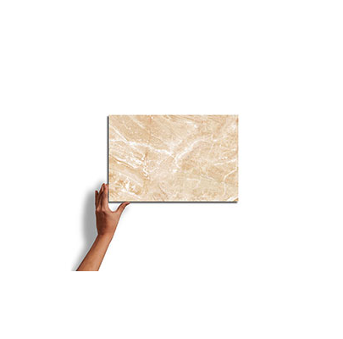

**LYPTUS HONEYWOD**

A beautifully glazed porcelain collection from Italy creates a blend of marbles with a subtle antiqued look. Blending the veining of white Italian marbles (Carrara, Statuario, Gioia, and Venatino) in both White and Black creates a variety of sizes and patterns to create custom designs.

SPECIFICATIONS

**Country of Origin**

Italy

**Wear Rating**

Class 5 Suitable for all Residential and Commercial Application. Class 5 tiles are suitable for all applications including those with heavy traffic and constant use. (i.e., Shopping Malls, Hospitals), Class 3 Residential Applications. Suitable for all residential applications.

**Shade Variation**

V3 - Moderate Variation While the colors present on a single piece of tile will be indicative of the colors to be expected on the other tiles, the amount of colors on each piece will vary significantly.

**Frost Proof**

Yes

**Finish**

Glazed

**Material**

Porcelain

**Bullnose**

Yes

**LIVING ROOM WALL TILES** TECHNICAL INFORMATION

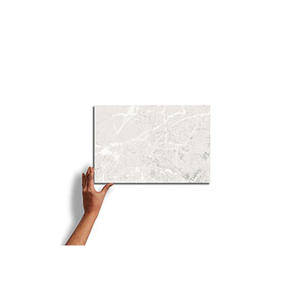

**ORFEO BUFF**

A beautifully glazed porcelain collection from Italy creates a blend of marbles with a subtle antiqued look. Blending the veining of white Italian marbles (Carrara, Statuario, Gioia, and Venatino) in both White and Black creates a variety of sizes and patterns to create custom designs.

SPECIFICATIONS

**Country of Origin**

Italy

**Wear Rating**

Class 5 Suitable for all Residential and Commercial Application. Class 5 tiles are suitable for all applications including those with heavy traffic and constant use. (i.e., Shopping Malls, Hospitals), Class 3 Residential Applications. Suitable for all residential applications.

**Shade Variation**

V3 - Moderate Variation While the colors present on a single piece of tile will be indicative of the colors to be expected on the other tiles, the amount of colors on each piece will vary significantly.

**Frost Proof**

Yes

**Finish**

Glazed

**Material**

Porcelain

**Bullnose**

Yes

**LIVING ROOM WALL TILES** TECHNICAL INFORMATION

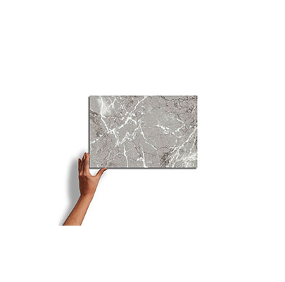

**DOUGHLAS FIR NATURAL**

A beautifully glazed porcelain collection from Italy creates a blend of marbles with a subtle antiqued look. Blending the veining of white Italian marbles (Carrara, Statuario, Gioia, and Venatino) in both White and Black creates a variety of sizes and patterns to create custom designs.

SPECIFICATIONS

**Country of Origin**

Italy

**Wear Rating**

Class 5 Suitable for all Residential and Commercial Application. Class 5 tiles are suitable for all applications including those with heavy traffic and constant use. (i.e., Shopping Malls, Hospitals), Class 3 Residential Applications. Suitable for all residential applications.

**Shade Variation**

V3 - Moderate Variation While the colors present on a single piece of tile will be indicative of the colors to be expected on the other tiles, the amount of colors on each piece will vary significantly.

**Frost Proof**

Yes

**Finish**

Glazed

**Material**

Porcelain

**Bullnose**

Yes

**LIVING ROOM WALL TILES** TECHNICAL INFORMATION

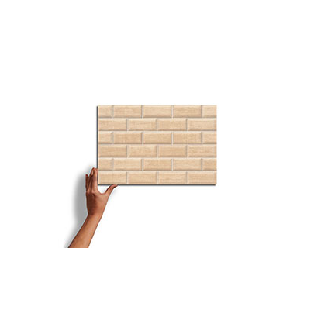

**LAUFEN GOLD DECOR**

A beautifully glazed porcelain collection from Italy creates a blend of marbles with a subtle antiqued look. Blending the veining of white Italian marbles (Carrara, Statuario, Gioia, and Venatino) in both White and Black creates a variety of sizes and patterns to create custom designs.

SPECIFICATIONS

**Country of Origin**

Italy

**Wear Rating**

Class 5 Suitable for all Residential and Commercial Application. Class 5 tiles are suitable for all applications including those with heavy traffic and constant use. (i.e., Shopping Malls, Hospitals), Class 3 Residential Applications. Suitable for all residential applications.

**Shade Variation**

V3 - Moderate Variation While the colors present on a single piece of tile will be indicative of the colors to be expected on the other tiles, the amount of colors on each piece will vary significantly.

**Frost Proof**

Yes

**Finish**

Glazed

**Material**

Porcelain

**Bullnose**

Yes

**LIVING ROOM WALL TILES** TECHNICAL INFORMATION

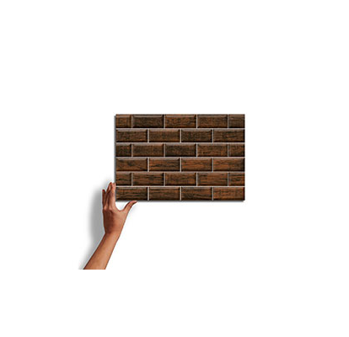

**LAUFEN BRUNETTE**

A beautifully glazed porcelain collection from Italy creates a blend of marbles with a subtle antiqued look. Blending the veining of white Italian marbles (Carrara, Statuario, Gioia, and Venatino) in both White and Black creates a variety of sizes and patterns to create custom designs.

SPECIFICATIONS

**Country of Origin**

Italy

**Wear Rating**

Class 5 Suitable for all Residential and Commercial Application. Class 5 tiles are suitable for all applications including those with heavy traffic and constant use. (i.e., Shopping Malls, Hospitals), Class 3 Residential Applications. Suitable for all residential applications.

**Shade Variation**

V3 - Moderate Variation While the colors present on a single piece of tile will be indicative of the colors to be expected on the other tiles, the amount of colors on each piece will vary significantly.

**Frost Proof**

Yes

**Finish**

Glazed

**Material**

Porcelain

**Bullnose**

Yes

**LIVING ROOM WALL TILES** TECHNICAL INFORMATION

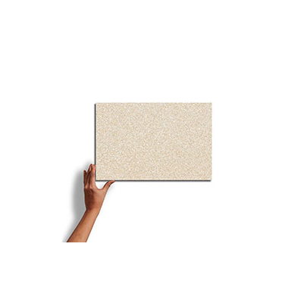

**LAUFEN GOLD**

A beautifully glazed porcelain collection from Italy creates a blend of marbles with a subtle antiqued look. Blending the veining of white Italian marbles (Carrara, Statuario, Gioia, and Venatino) in both White and Black creates a variety of sizes and patterns to create custom designs.

SPECIFICATIONS

**Country of Origin**

Italy

**Wear Rating**

Class 5 Suitable for all Residential and Commercial Application. Class 5 tiles are suitable for all applications including those with heavy traffic and constant use. (i.e., Shopping Malls, Hospitals), Class 3 Residential Applications. Suitable for all residential applications.

**Shade Variation**

V3 - Moderate Variation While the colors present on a single piece of tile will be indicative of the colors to be expected on the other tiles, the amount of colors on each piece will vary significantly.

**Frost Proof**

Yes

**Finish**

Glazed

**Material**

Porcelain

**Bullnose**

Yes

NOTES

Always inspect materials prior to installation.

Always mix 2-3 cartons at a time while installing to insure the best blend.

Per ANSI standard A108.02,4.3.82, tiles longer than 18” should not be staggered more than 1/3

the length of the tile.

All product images are representation only. Variation in color and shading is to be expected.

Final selection should be made from actual tile samples.